**19th June 2023**

**QUARTERLY PROJECT STATUS REPORT**

**January 2023 to April 2023**

**PROJECT SUMMARY**

|  |  |  |  |  |  |
| --- | --- | --- | --- | --- | --- |
| REPORT DATE | PROJECT  NAME | PROJECT  COORDINATORS | CHILDREN ENROLLED | TEACHERS EMPLOYED | SUPPORT STAFF EMPLOYED |
| 30/4/2023 | IMESA Saharanpur | Majid Jamil  Honorary | 120 | Two Teachers and one trainer | NIL |

**STATUS SUMMARY**

Please provide summary of all the key achievements from the last quarter

**Objectives of the project**

The Project aimed to support the Children from economically and educationally poor families in socio economically backward localities in Saharanpur (U.P.) city.

The project helped in setting up the special classes at two locations, one in Mohalla Quazi and other in Nakhasa Bazar. The Children attended classes under supervision of two qualified teachers.

Most of the students belong to very poor families of house maids, rickshaw pullers, labourer’s etc. Students from slums are also attending this class.

Number of beneficiaries:

The classes under the project started initially at one place with around 50 children but now the number of students increased to more than 100 with two centres located at two different locations. These students belong to the poor families of neighbouring areas.

**Capacity of beneficiaries before the project:**

The children did not have proper facilities in their homes to study and do daily homework or prepare for exams at these two libraries. Their parents are not educated and could not help their work in basic studies. General atmosphere in these localities lack discipline and unless the children are given proper guidance, they fail in early classes and generally drop out of school.

**Brief methodology:**

The Project began in 2015 as local team got together and held meetings to prepare and plan the project. Campaign among local students and their parents began to join the free coaching and Guidance Centre. It look couple of weeks to make necessary preparation. Registration of students began within a day 45 students enrolled. Interview were held to appoint teachers and support staff. Qualified teachers were selected.

Coaching classes run between 4pm -8pm, six days a week.

Hindi, Urdu, English, Mathematics Social Study Science and general knowledge are taught in the class. Homework is done by the students with the help of teacher.

Extra-curricular activities and regular games kept students engaged for overall development.

**BUDGET SUMMARY**

**Staff at Saharanpur Centre**

|  |  |  |  |  |
| --- | --- | --- | --- | --- |
| **Name of the employee** | **Designation** | **Date of appointment** | **Date of extension** | **Monthly Salary** |
| Mr. Mohd Saleem | Teacher | 01/01/2018 | 01/03/2023 till 31/01/ 2024 | Rs. 5000/- |
| Ms. Baby Siora | Teacher | 01/06/2022 | 01/03/2023 till 31/01/ 2024 | Rs.3000/- |
| Ms. Aman | Trainer | 01/06/2022 | 01/03/2023 till 31/01/ 2024 | Rs. 2000/- |

**Total: Rs. 10,000 per month**

**RISK AND ISSUES SUMMARY**

Please highlight any key risk and issues:

|  |  |  |  |
| --- | --- | --- | --- |
| RISK / ISSUES | RAISED BY | STATUS | NOTES |
|  | Project coordinators | Raised in the quarterly executive meeting held on 30.1.2023 |  |
| Delay in salary | Majid Jamil | Sometimes, there is a delay in payment to teachers. It should be ensured that the teachers and other staff get their salaries in time | . |

**CONCLUSION / RECOMMENDATIONS**

**From January 2023 to April 2023, students attended classes regularly. More than 100 children at two libraries of Saharanpur Centre joined evening classes. Teachers worked hard with the students.**

**We are planning to expand the activities at Saharanpur Centre with one more library. The expanded activities would be within the budget limits decided by IMESA for one Centre. The details of the staff are given below.**

**The staff has been appointed and has started working from 1 June 2023.**

**Staff at Saharanpur Centre**

|  |  |  |  |  |
| --- | --- | --- | --- | --- |
| **Name of the employee** | **Designation** | **Date of appointment** | **Date of extension** | **Monthly Salary** |
| Mr. Mohd Saleem | Teacher | 01/01/2018 | 01/03/2023 till 31/01/ 2024 | Rs. 7500/- |
| Ms. Baby Sifora | Teacher | 01/06/2022 | 01/03/2023 till 31/01/ 2024 | Rs.3000/- |
| Ms. Aman | Trainer | 01/06/2022 | 01/03/2023 till 31/01/ 2024 | Rs. 3000/- |
| Ms. Alfiyya Omar | Teacher | 01/06/2023 | 01/06/2023 till 31/01/ 2024 | Rs. 7500/- |
| Mr. Mohd. Irfan Ansari | Coordinator | 01/06/2023 | 01/06/2023 till 31/01/ 2024 | Rs. 4000/ |
| Total . **Rs. 25,000/=** | | | | |

**Infrastructure**: Please pay onetime, payment of Rs. 25,000/- for infrastructure. It may also be transferred into the account of Mr. Irfan Ansari, coordinator.

**Thanks and looking forward for continuing the support from IMESA.**

**Wishing all success for all the projects.**

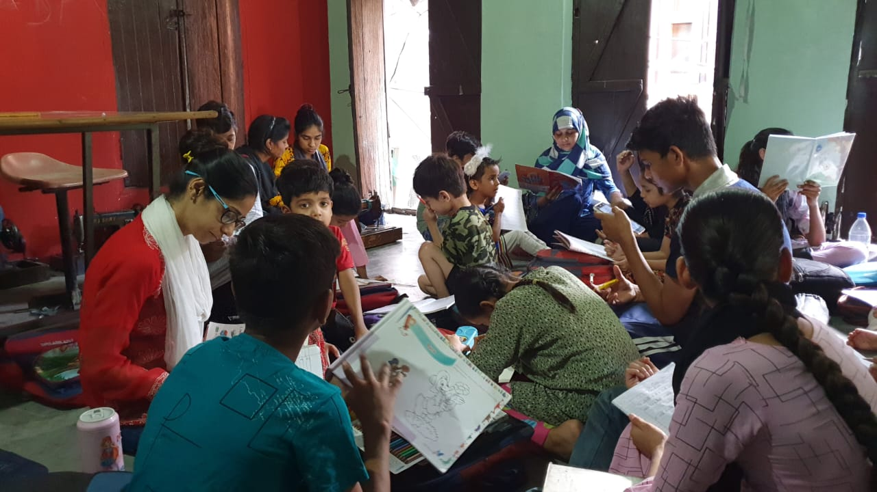

**Recent Photos**



